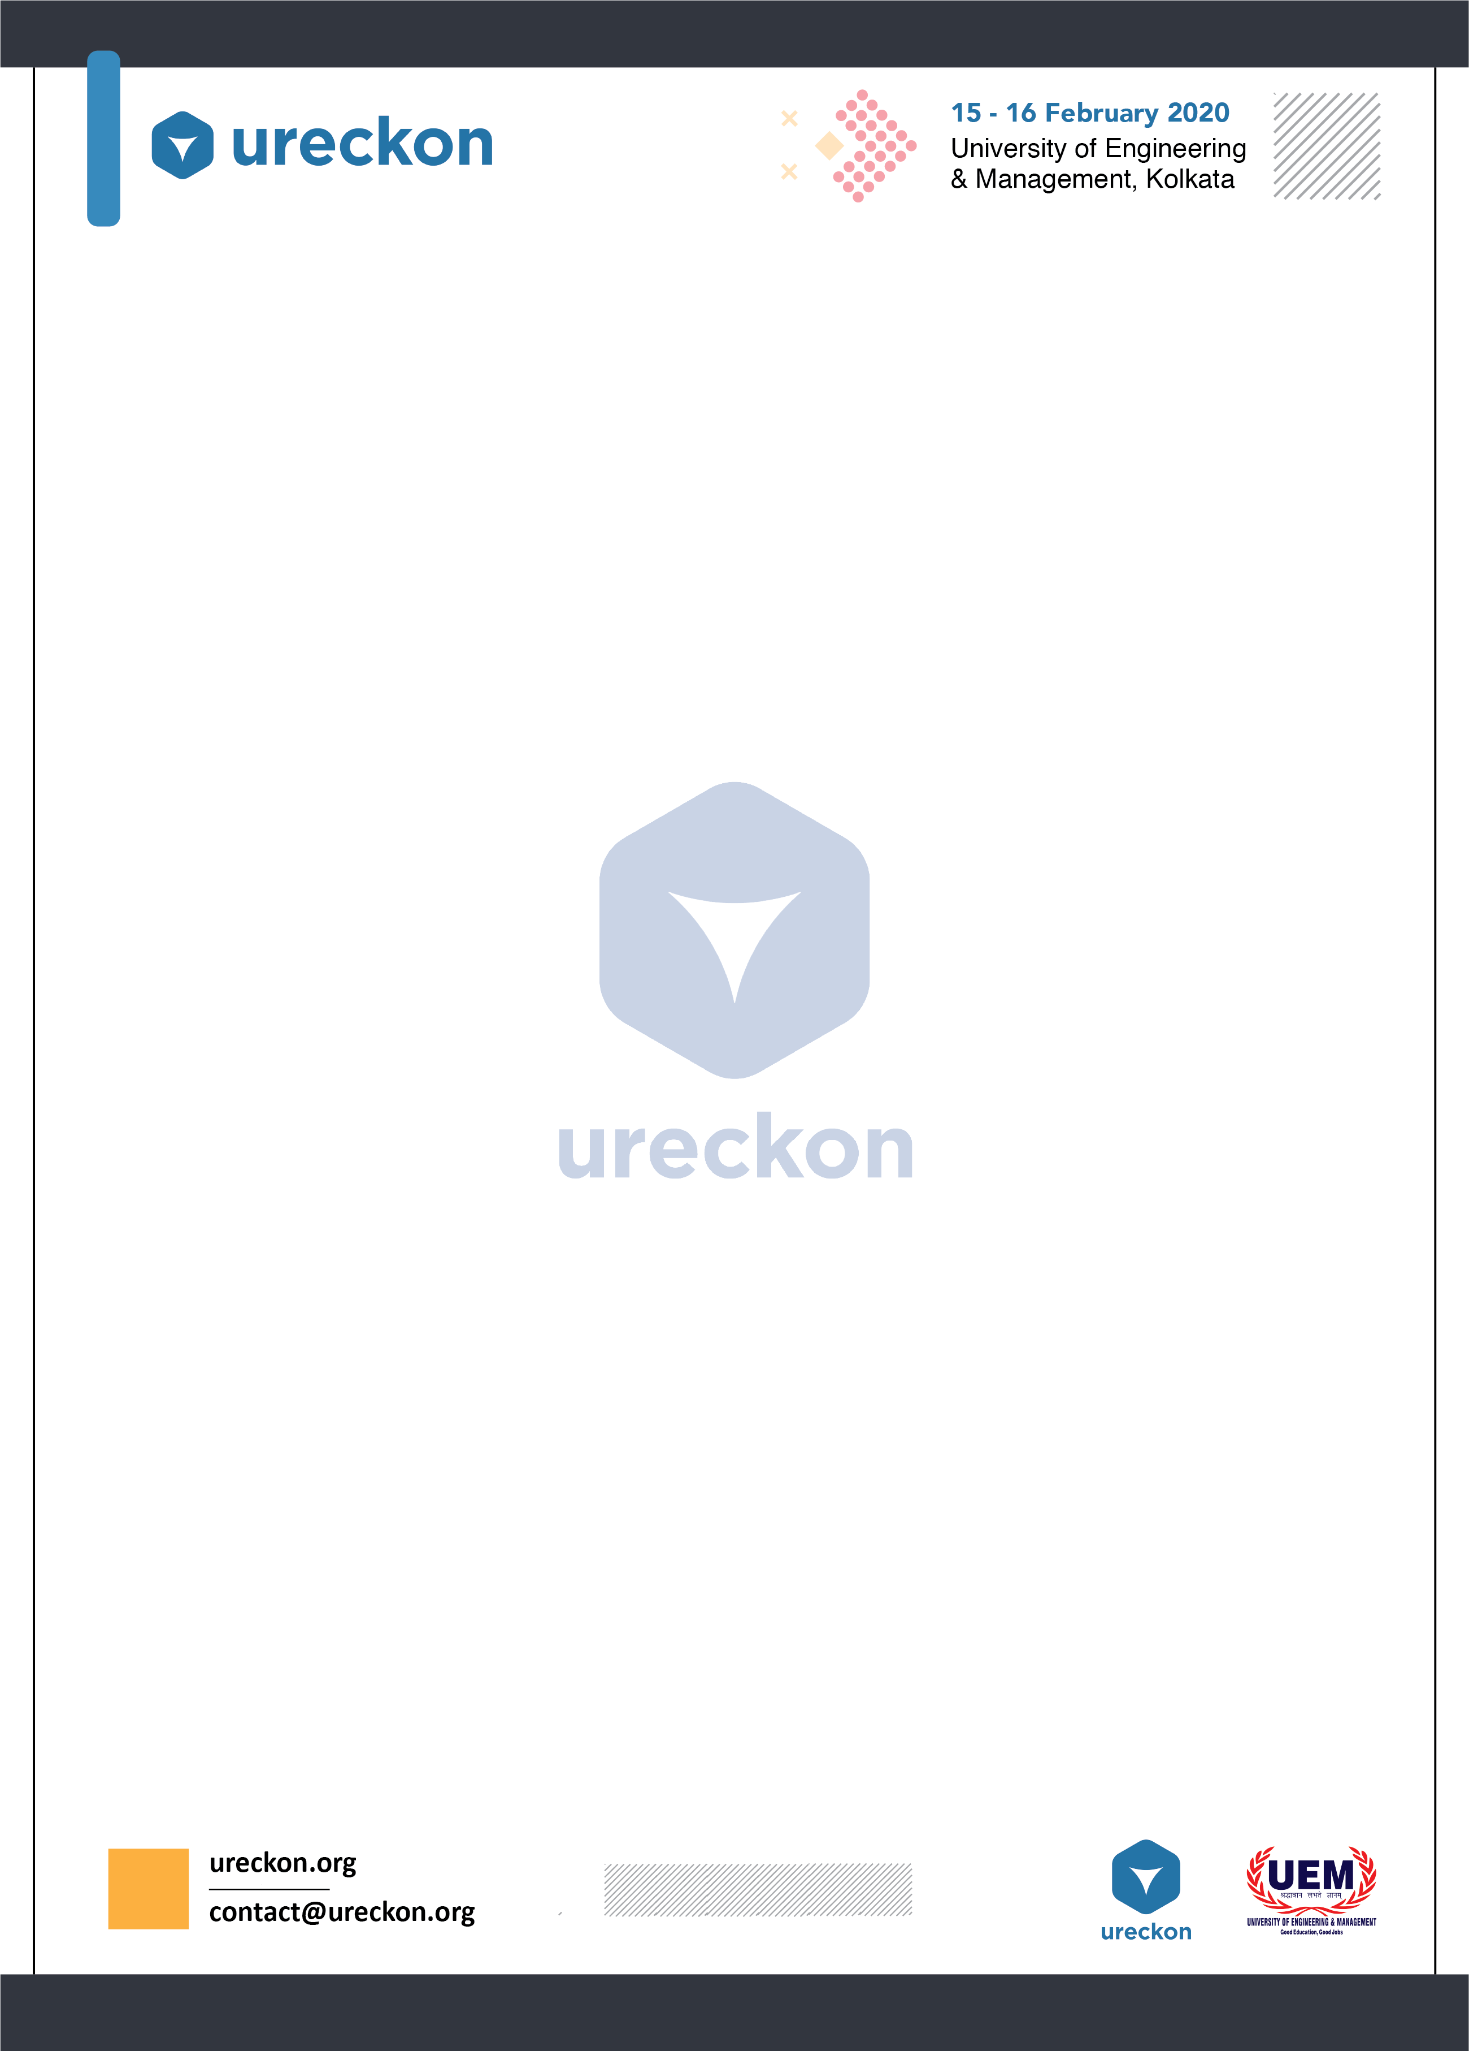**CYBER CIPHER**

**“Knowing is not enough; we must apply. Willing is not enough; we must do.” - Johann Wolfgang von Goethe.**

CTF is a kind of information security event where participants have to solve real life ethical hacking challenges . CYBER CIPHER is an ethical hacking contest in which certain pieces of information called ‘flags’ are hidden in the challenges. Bring a team ready to be tested in cryptography, steganography, cyber forensics, binary exploitation, reverse engineering and other real world problems on their way to capture the flag.

CTF Type: Jeopardy

**Rules & Regulations:**

* Maximum size of the team can be of three members,but solo participation is also allowed.
* Any kind of resource exhaustion attacks like DDOS are not allowed.
* Don’t delete flags or break services.
* Participants have to carry their own systems with all required tools.
* All participants are requested to carry their college’s ID card.
* The decisions of the co-ordinators regarding all matters shall be final

Rounds:

* Qualification Round:

The qualification round will be a MCQ round consist of 20 questions.Each question will have a weightage of 1 mark.

* Final Round:

Final round will be online jeopardy style.There will be 6 questions from following categories:

* WEB-Web technologies and vulnerabilities.
* Forensics-analyzing data formats,logs and files.
* Reverse engineering-understand the algorithm of an executable
* Cryptography-analyzing different encryption techniques.

Sample Questions:

Ram is a noob when it comes to steganography!

Help him to find out the flag from the given image.

Practice more such questions from:

<http://reversing.kr/>

[**https://www.vulnhub.com/**](https://www.vulnhub.com/)

Regards,

Sangramjit Maity.

Tathagata Rudra.